# Name :- Sarthak Pagar

# Roll No. :- 40

# Class :- TE(IT)

# Practical 7A :- Perform the following data visualization operations using Tableau on Adult datasets.

a. 1D (Linear) Data visualization

b. 2D (Planar) Data Visualization

c. 3D (Volumetric) Data Visualization

d. Temporal Data Visualization

e. Multidimensional Data Visualization

f. Tree/ Hierarchical Data visualization

g. Network Data visualization

a.

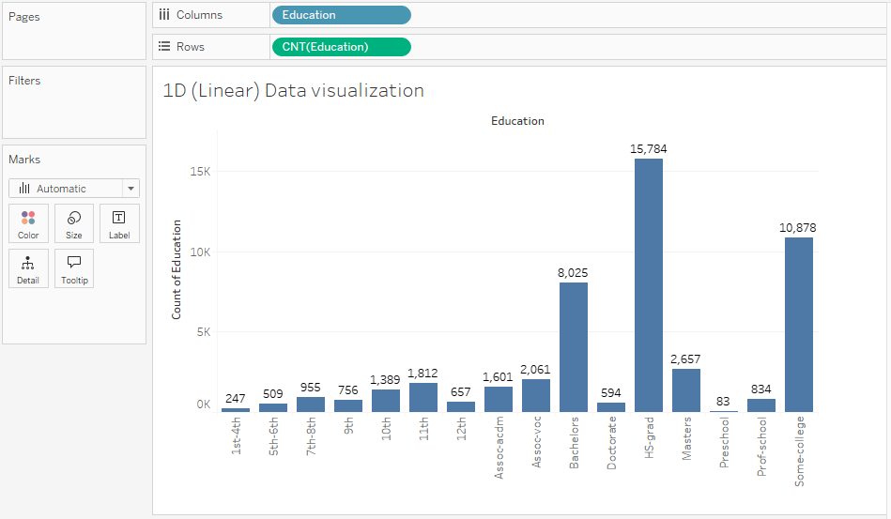

b.

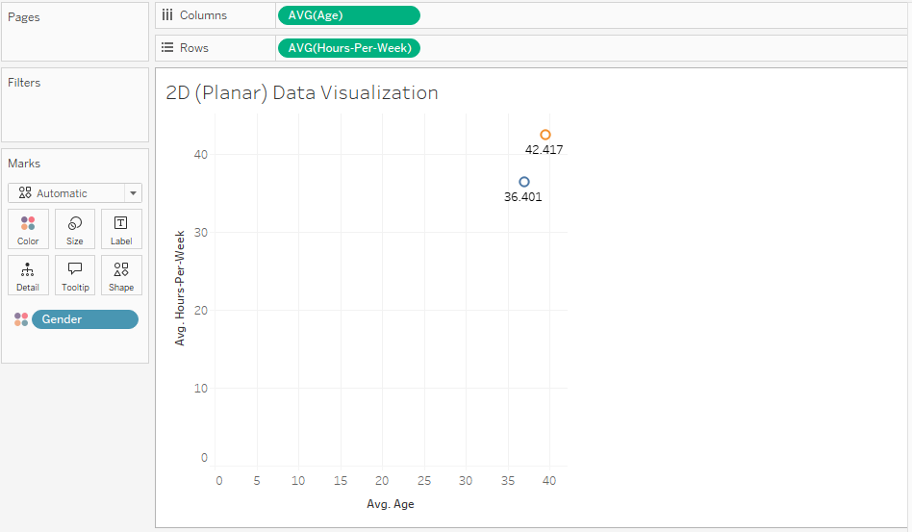

c.

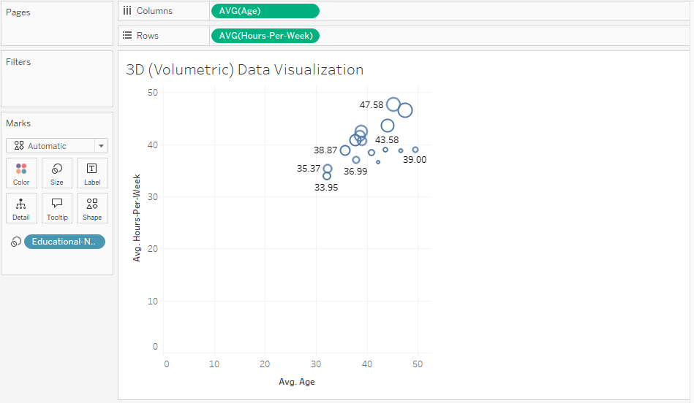

For d, there is no time related data. So, we used create a calculated field with...

"Birth Year" = YEAR(TODAY()) - [age]

d.

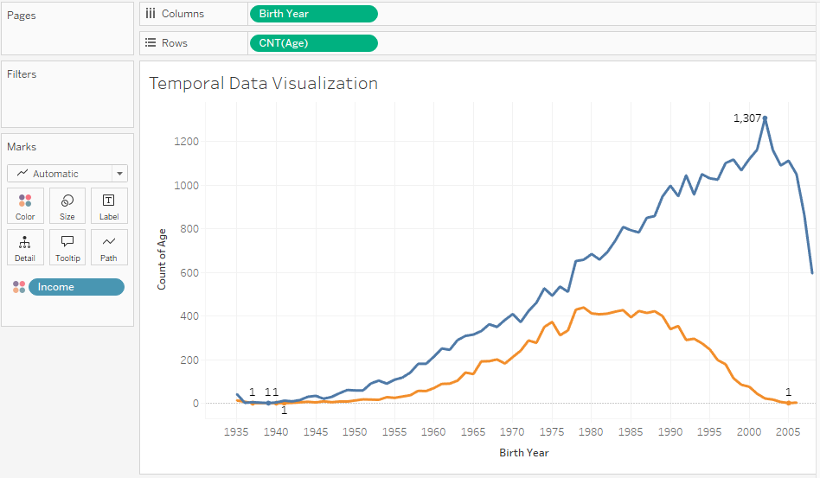

e.

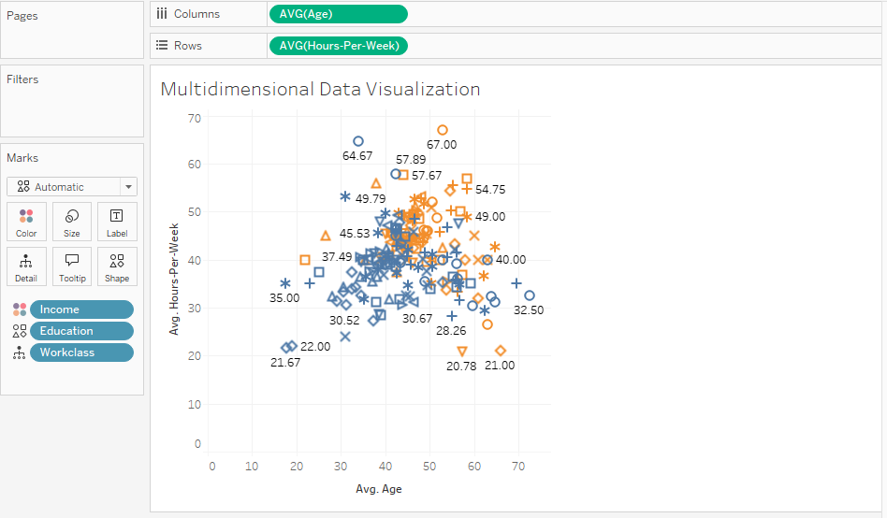

f.

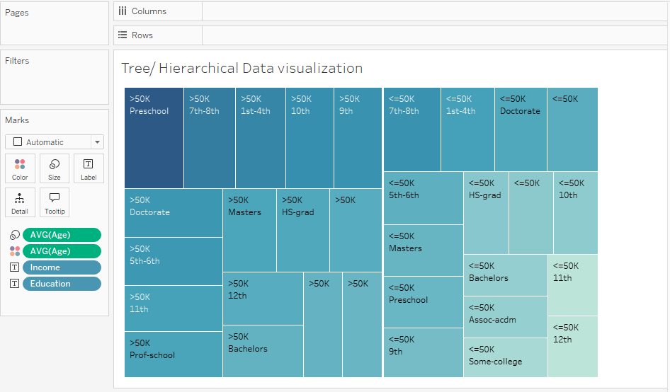

For g, we have used external extension “Network Diagram”.

g.

